Structured Output
22.06.2025

Structured Output
Refers to the practice of having language models return responses in a well defined data format (for e.g. JSON) rather than free-form text. This makes the model easier to parse and work with programmatically.
E.g. Use Cases - Data Extraction , API building , Agents etc.

Some LLMs can give responses in structured format but some can’t.
Those can send use the function : with_structured_output
Those can’t : output parsers

with_structured_output
You just need to call the function with a specific data format. E.g Typedict , Pydantic and Json schema. Typedict and Pydantic are function calls.

- Typedict : a way to define a dictionary in python where you specify what keys and values should exist. It does not validate just help with type hints for better coding.
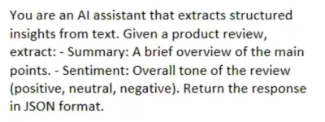
{name : str , age : int }
At the backend it converts the given data format in a template to print results like this.

- Pydantic : a data validation and data parsing library for python. It ensures the data you work with is correct , structured and type-safe. It offers constraints , default values etc.

- Json : when you use multiple languages and you want all of them to understand your schema , a standard json format.

It is suggested to use json data format with openAI.
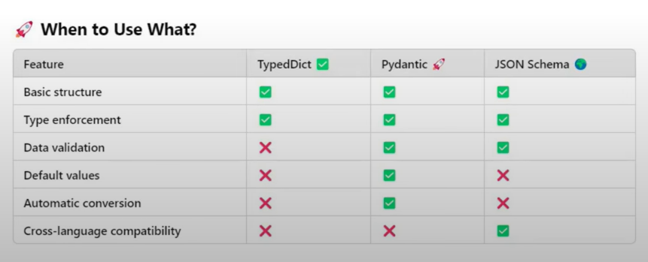

Output Parsers
They help to convert raw LLMs responses into structured format like JSON , CSV , pydantic models etc. They ensure consistency , validation and ease of use.
They can work with models that can give structured outputs and also that can’t.

Mainly 4 types of output parsers :
StrOP , JsonOP , StructuredOP , PydanticOP

StrOutputParser
Simplest output parser used to parse the output of a LLM and return it as plain string.
E.g. there is no need of (result.content). We can use this OP instead of it. We can use it with chains to directly use the output of a LLM for the next task.

JSONOutputParser
Forces the LLM to send its output in JSON format.
Its drawback is that it cannot enforce a schema i.e. not sure the output is in the format I want.

StructuredOutputParser
It helps to extract structured JSON data from LLM responses based on predefined field schemas.
The main disadvantage is lack of data validation i.e. can be different data types as required.

PydanticOutputParser
Use pydantic models to enforce schema validation when processing LLM responses.

